MALLA REDDY COLLEGE OF ENGINEERING & TECHNOLOGY

(AUTONOMOUS INSTITUTION – UGC, GOVT. OF INDIA)

Department of CSE
B. TECH (R-22) (IV YEAR– I SEM)
(2026-2027)

DATASCIENCE LAB
(R22A6784)
LAB MANUAL

MALLA REDDY COLLEGE OF ENGINEERING & TECHNOLOGY

(Autonomous Institution – UGC, Govt. of India)

Recognized under 2(f) and 12(B) of UGC ACT 1956
(Affiliated to JNTUH, Hyderabad, Approved by AICTE-Accredited by NBA & NAAC – ‘A’ Grade - ISO 9001:2015 Certified)
Maisammaguda, Dhulapally (Post Via. Hakimpet), Secunderabad–500100, Telangana State, India

Vision
Department of Computer Science and Engineering
DATA SCIENCE LAB

- “To be at the forefront of Data Science and to evolve as a Centre of Excellence in Research, Learning and Consultancy to foster the students into globally competent professionals useful to the Society.”

Mission
The department of CSE is committed to:
- To offer highest Professional and Academic Standards in terms of Personal growth and satisfaction.
- Make the society as the hub of emerging technologies and thereby capture opportunities in new age technologies.
- To create a benchmark in the areas of Research, Education and Public Outreach.
- To provide students a platform where independent learning and scientific study are encouraged with emphasis on latest engineering techniques.

QUALITY POLICY
- To pursue continual improvement of teaching learning process of Undergraduate and Post Graduate programs in Engineering & Management vigorously.
- To provide state of art infrastructure and expertise to impart the quality education and research environment to students for a complete learning experiences.
- Developing students with a disciplined and integrated personality.
- To offer quality relevant and cost-effective programmes to produce engineers as per requirements of the industry need.

For more information: www.mrcet.ac.in

MRCET CAMPUS |AUTONOMOUS INSTITUTION-UGC,GOVT.OFINDIA
IV Year B. Tech CSE–I Sem(R22) L/T/P/C

-/-/2/1

DATA SCIENCE LAB(R22A6784)
Course Outcomes:
At the end of the Course, the Student will be able to:
- Show the installation of R Programming Environment.
- Utilize and R Data types for developing programs
- Make use of different R Data Structures.
- Develop programming logic using R Packages.
- Analyze the data sets using R programming capabilities.
LIST OF PROGRAMS:
- Download and install R-Programming environment and install basic packages using install. Packages () command in R.
- Learn all the basics of R-Programming (Data types
, Variables , Operators etc.)
- Implement R-Loops with different examples.
- Learn the basics of functions in R and implement with examples.
- Write R programs using Matrices, Arrays, Lists, Vectors and Factors.
- Write R programs using Data Frames.

- Write R programs to read a file into a data frame and display it (CSV and Excel).
- Write R program to write a data frame to a file and display it.
- Write an R program to Connect to a database and read the data.
- Implement a) Linear regression model and b) Logistic regression model of any data set and print confusion matrix, precision recall, F1 score, AUC curve.
- Write R script to plot Bar Chart, Pie Chart, Histogram, Box plot, Dot plot
- Use ggplot2 and implement 1) Univariate, 2) Bivariate graphs

INDEX
S.No | List of Programs
1 | Download and install R-Programming environment and install basic packages using install packages () command in R.
2 | Learn all the basics of R-Programming (Data types, Variables Operators etc.)
3 | Implement R-Loops with different examples.
4 | Learn the basic of functions in R and implement with examples.
5 | Write R programs using Matrices, Arrays, Lists, Vectors and Factors.
6 | Write R programs using Data Frames.
7 | Write R programs to read a file into a data frame and display it (CSV and Excel).
8 | Write R program to write a data frame to a file and display it.
9 | Write an R program to Connect to a database and read the data.
10 | Implement a) Linear regression model and b) Logistic regression model of any data set and print confusion matrix, precision recall,  F1 score, AUC curve
11 | Write R script to plot Bar Chart, Pie Chart, Histogram, Box plot, Dot plot
12 | Use ggplot2 and implement 1) Univariate, 2) Bivariate graphs

Brief Introduction of R Programming Language :

R is an open-source programming language that is widely used as a statistical software and data analysis tool. R generally comes with the Command-line interface. R is available across widely used platforms like Windows, Linux, and macOS. Also, the R programming language is the latest cutting-edge tool.
It was designed by Ross Ihaka and Robert Gentleman at the University of Auckland, New Zealand, and is currently developed by the R Development Core Team. R programming language is an implementation of the S programming language. It also combines with lexical scoping semantics inspired by Scheme. Moreover, the project conceives in 1992, with an initial version released in 1995 and a stable beta version in 2000.

Use of R Programming :
- It’s a platform-independent language. This means it can be applied to all operating system.
- It’s an open-source free language. That means anyone can install it in any organization without purchasing a license.
- R programming is used as a leading tool for machine learning, statistics, and data analysis. Objects, functions, and packages can easily be created by R.
- R programming language is not only a statistic package but also allows us to integrate with other languages (C, C++). Thus, can easily interact with many data sources and statistical packages.
- The R programming language has a vast community of users and it’s growing day by day.
- R is currently one of the most requested programming languages in the Data Science job market that makes it the hottest trend nowadays

Installation of R-Studio on windows:

Step – 1: With R-base installed, let’s move on to installing RStudio. To begin, goto download RStudioand click on the download button for RStudio desktop.
Step–2: Click on the link for the windows version of RStudio and save the.exe file.
Step–3: Run the .exe and follow the installation instructions. Click Next on the welcome window.
Enter/ browse the path to the installation folder and click Next to proceed.
Select the folder for the start menu shortcut or click on do not create shortcuts and then click Next. Wait for the installation process to complete.

Click Finish to end the installation.

Output :

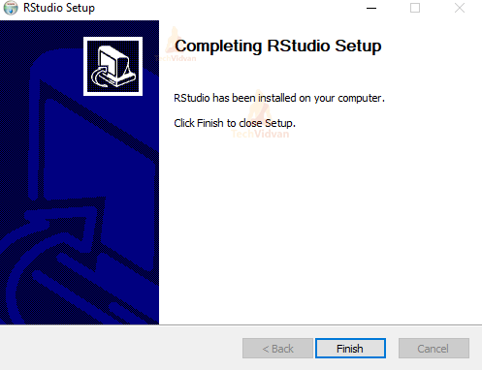

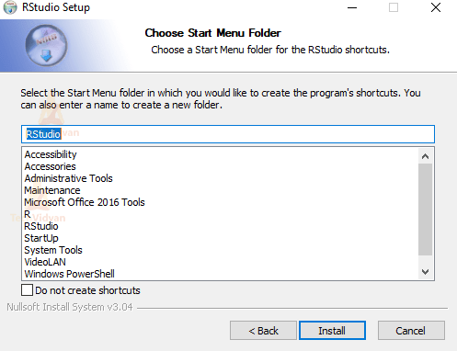

Install the R Packages:-

- First, run RStudio.
- After clicking on the packages tab, click on install. The following dialog box will appear.
- In the Install Packages dialog, write the package name you want to install under the Packages field and then click install. This will install the packageyousearchedfororgiveyoualistofmatchingpackagesbasedonyour package text.

Installing Packages:-Loading Packages:-
Once the package is downloaded to your computer you can access the functions and
Resources provided by the package in two different ways: #load the package to use in the current R session
library (package name)

Getting Help on Packages:-

"C:/Program Files/R/R-3.2.2/library"

install.packages("Package Name")
# Install the package named "XML". install.packages("XML")

Learn all the basics of R-Programming (Data types, Variables, Operators etc.)

Program Description :
Variables are nothing but reserved memory locations to store values. This means that, when create a variable you reserve some space in memory.
A variable provides us with named storage that our programs can manipulate. A variable in R can store an atomic vector, group of atomic vectors or a combination of many R objects. A valid variable name consists of letters, numbers and the dot or underline characters. The variable name starts with a letter or the dot not followed by a number.
An operator is a symbol that tells the compiler to perform specific mathematical or logical manipulations. R language is rich in built-in operators and provides following types of operators.
Data Types:

Numeric:
v <-23.5
print(class(v))

Logical
v <- TRUE
print(class(v))
Integer v <-2L
print(class(v))

Output :
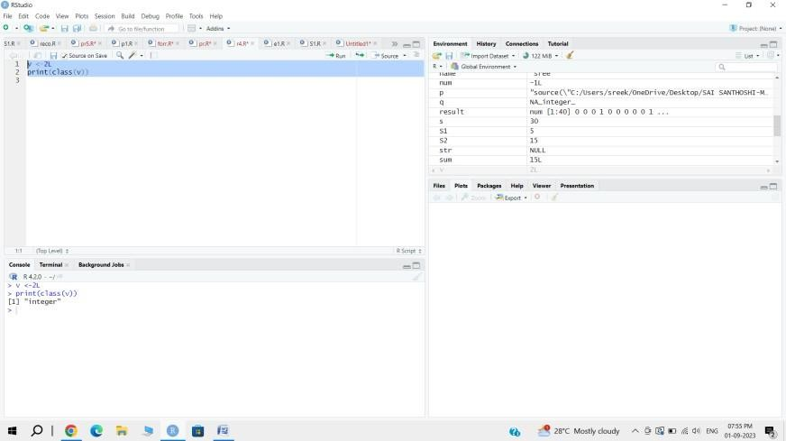

R-objects.
  - Vectors
  - Lists
  - Matrices
  - Arrays
  - Factors
  - Data Frames

Vectors
When you want to create vector with more than one element, you should use c() function which means to combine the elements into a vector.
# Create a vector.
apple <- c('red','green',"yellow") print(apple)

# Get the class of the vector. print(class(apple))

Output :

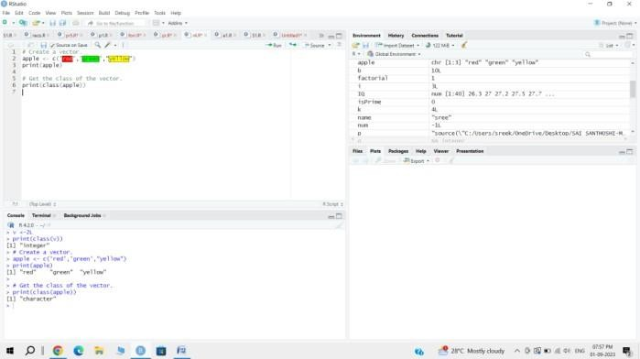

Lists
A list is an R-object which can contain many different types of elements inside it like vectors, functions and even another list inside it.

# Create a list.
list1 <- list(c(2,5,3),21.3,sin)

# Print the list. print(list1)

Output :

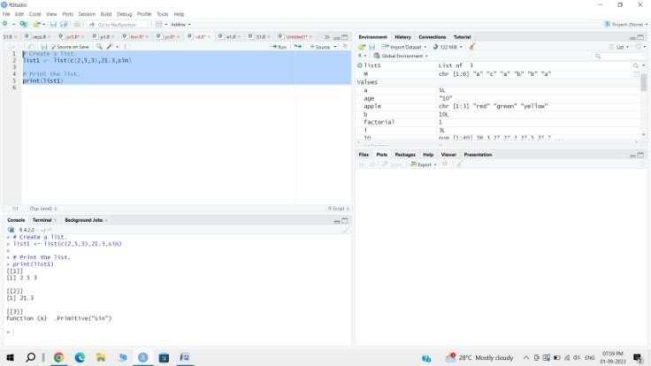

Matrices
A matrix is a two-dimensional rectangular data set. It can be created using a vector input to the matrix function.
# Create a matrix.
M =matrix( c('a','a','b','c','b','a'),nrow=2,ncol=3,byrow= TRUE) print(M)

Output :
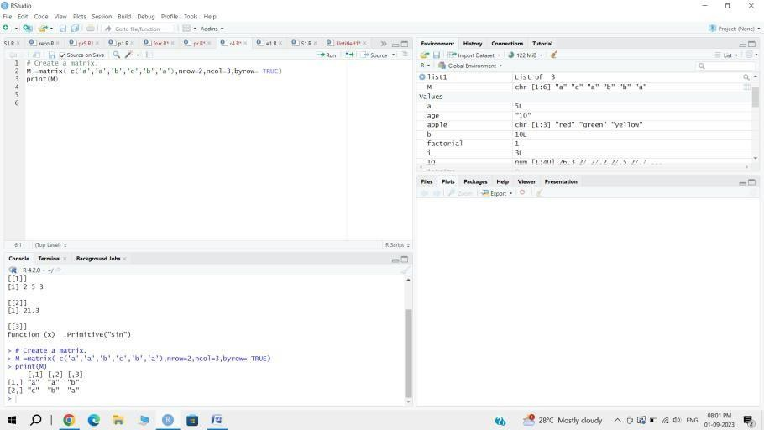

Arrays
While matrices are confined to two dimensions, arrays can be of any number of dimensions. The array function takes a dim attribute which creates the required number of dimension. In the below example we create an array with two elements which are 3x3 matrices each.

# Create an array.
a <- array(c('green','yellow'),dim= c(3,3,2)) print(a)

Output :

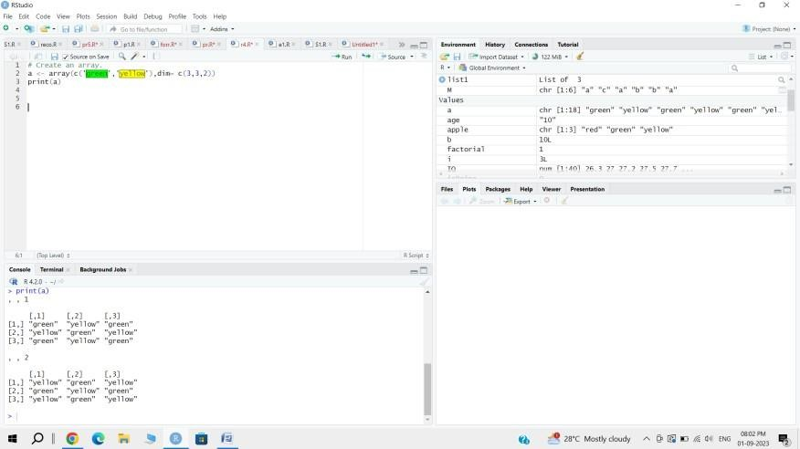

Factors
Factors are the R-objects which are created using a vector. It stores the vector along with the distinct values of the elements in the vector as labels. The labels are always character irrespective of whether it is numeric or character or Boolean etc. in the input vector. They are useful in statistical modeling.
Factors are created using the factor() function. The n levels functions gives the count of levels.

# Create a vector.
apple_colors<- c('green','green','yellow','red','red','red','green')

# Create a factor object. factor_apple<- factor(apple_colors)

# Print the factor. print(factor_apple) print(nlevels(factor_apple))
[1] green green yellow red redred green Levels: green red yellow

Output :

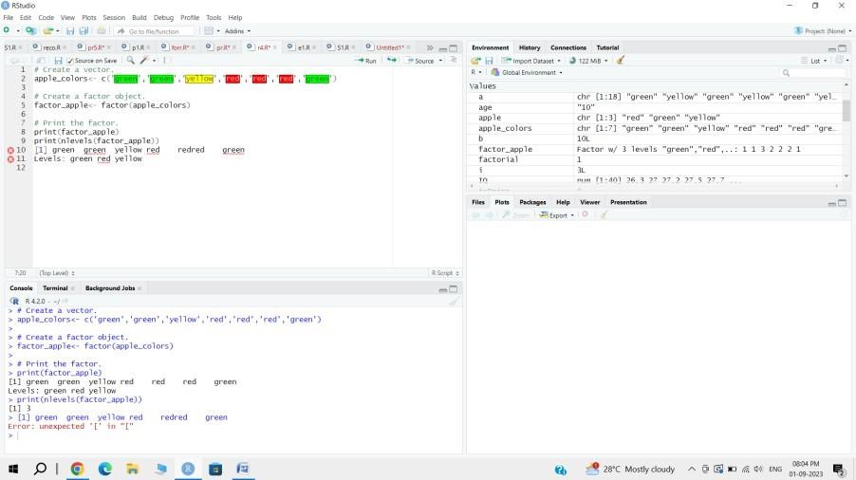

Variables:

The variables can be assigned values using leftward, rightward and equal to operator. The values of the variables can be printed using print() or cat() function. The cat() function combines multiple items into a continuous print output.
# Assignment using equal operator. var.1=c(0,1,2,3)
# Assignment using leftward operator. var.2<- c("learn","R")
# Assignment using rightward operator. c(TRUE,1)->var.3

print(var.1)
cat ("var.1 is ",var.1,"\n")
cat ("var.2 is ",var.2,"\n")
cat ("var.3 is ",var.3,"\n")

Output :
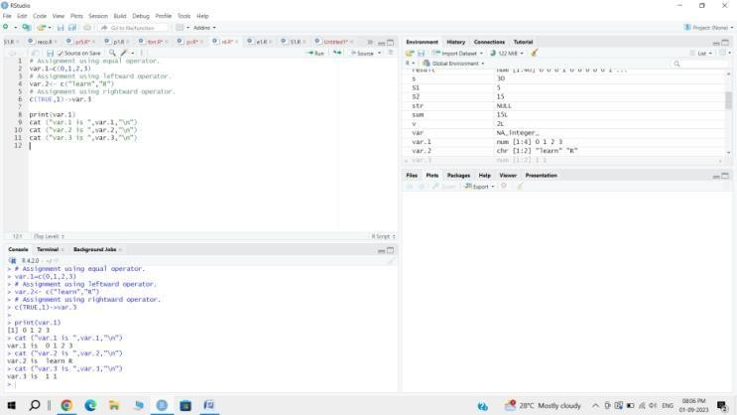

R Operators :
Types of Operators

Arithmetic Operators
v <- c( 2,5.5,6)
t <- c(8, 3, 4)
print(v+t)

Relational Operators

v <- c(2,5.5,6,9)
t <- c(8,2.5,14,9)
print(v>t)

Logical Operators

v <- c(3,1,TRUE,2+3i) t <- c(4,1,FALSE,2+3i)
print(v&t)
Assignment Operators v1 <- c(3,1,TRUE,2+3i) v2 <<- c(3,1,TRUE,2+3i) v3 = c(3,1,TRUE,2+3i)
print(v1) print(v2) print(v3)

Output :
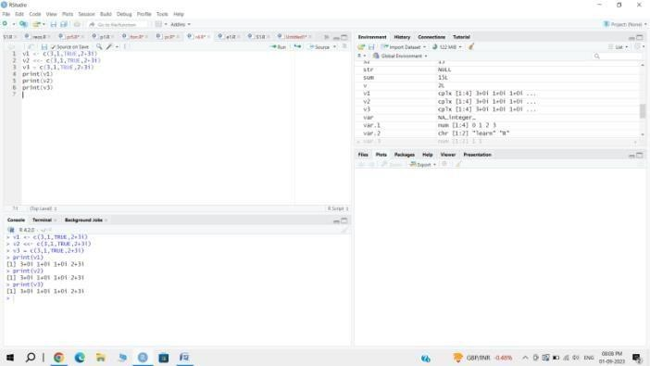

3 Implement R-Loops with different examples.

Program Description :
A for loop is the most popular control flow statement. A for loop is used to iterate a vector. It is similar to the while loop. There is only one difference between for and while, i.e., in while loop, the condition is checked before the execution of the body, but in for loop condition is checked after the execution of the body.

# Create fruit vector
fruit <- c('Apple', 'Orange',"Guava", 'Pinapple', 'Banana','Grapes') # Create the for statement
for ( i in fruit){ print(i)
}

Output :

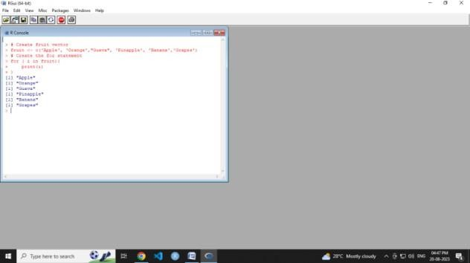

# Creating a matrix

mat <- matrix(data = seq(10, 21, by=1), nrow = 6, ncol =2) # Creating the loop with r and c to iterate over the matrix for (r in 1:nrow(mat))
for (c in 1:ncol(mat))
print(paste("mat[", r, ",",c, "]=", mat[r,c])) print(mat)

Output :

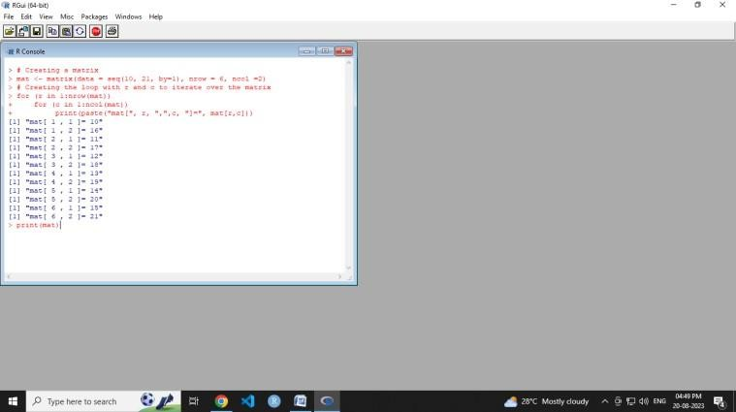

R while loop :
A while loop is a type of control flow statements which is used to iterate a block of code several numbers of times. The while loop terminates when the value of the Boolean expression will be false.

In while loop, firstly the condition will be checked and then after the body of the statement will execute. In this statement, the condition will be checked n+1 time, rather than n times.

v <- c("Hello","while loop") cnt <- 2
while (cnt < 7) { print(v)
cnt = cnt + 1
}

Output :

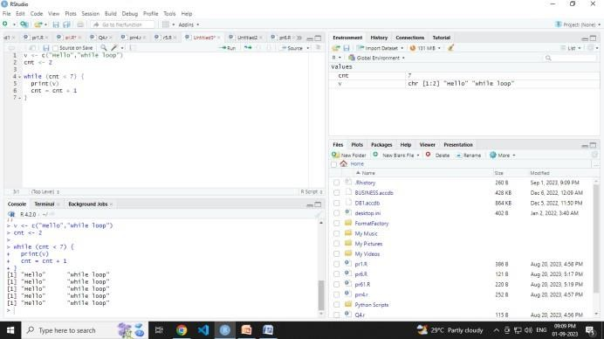

Learn the basics of functions in R and implement with examples.

Program Description :

A function is a set of statements organized together to perform a specific task. R has a large number of in-built functions and the user can create their own functions.
In R, a function is an object so the R interpreter is able to pass control to the function, along with arguments that may be necessary for the function to accomplish the actions.
The function in turn performs its task and returns control to the interpreter as well as any result which may be stored in other objects.

Built-in Function

# Create a sequence of numbers from 32 to 44. print(seq(32,44))

# Find mean of numbers from 25 to 82. print(mean(25:82))
# Find sum of numbers frm 41 to 68. print(sum(41:68))

Output :

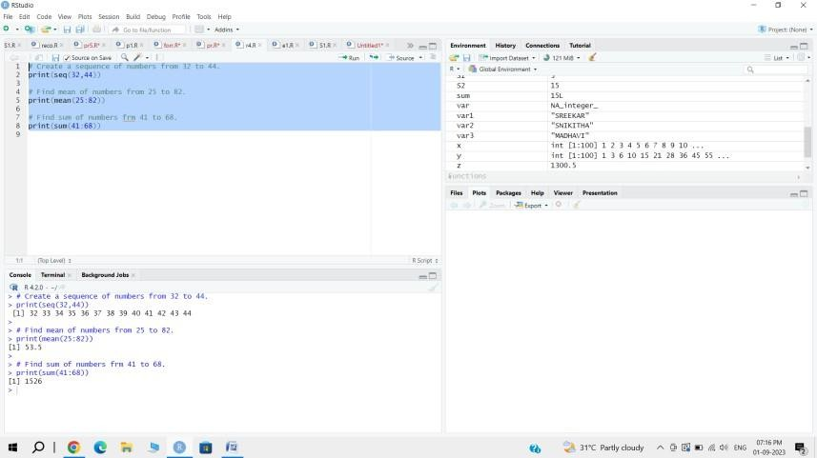

User-defined Function
We can create user-defined functions in R. They are specific to what a user wants and once created they can be used like the built-in functions. Below is an example of how a function is created and used.
# Create a function to print squares of numbers in sequence. new.function <- function(a) {
for(i in 1:a) { b <- i^2 print(b)
}
}
# Call the function new.function supplying 6 as an argument. new.function(6)

- Write R programs using Matrices, Arrays, Lists, Vectors and Factors

Program Description:

Vectors are the most basic R data objects and there are six types of atomic vectors. They are logical, integer double, complex, character and raw. Lists are the R objects which contain elements of different types like − numbers, strings, vectors and another list inside it. A list can also contain a matrix or a function as its elements. List is created using list() function.
.

Vectors
# Create a vector.
apple <- c('red','green',"yellow") print(apple)

# Get the class of the vector. print(class(apple))

OUTPUT:

[1] "red" "green" "yellow"
[1] "character"

Lists
A list is an R-object which can contain many different types of elements inside it like vectors, functions and even another list inside it.

# Create a list.
list1 <- list(c(2,5,3),21.3,sin)
# Print the list.
print(list1)
function (x) .Primitive("sin")

Output:

[[1]]
[1] 2 5 3

[[2]]
[1] 21.3

[[3]]
function (x) .Primitive("sin")

[1] 2 5 3
function (x)
.Primitive("sin")

Matrices
A matrix is a two-dimensional rectangular data set. It can be created using a vector input to the matrix function.

# Create a matrix.
M =matrix( c('a','a','b','c','b','a'),nrow=2,ncol=3,byrow= TRUE)
print(M)

Output:
[,1] [,2] [,3]
[1,] "a" "a" "b"
[2,] "c" "b" "a"

Arrays
Arrays are multi-dimensional data objects that store homogeneous data (elements of the exact same data type).
While vectors are one-dimensional and matrices are strictly two-dimensional, arrays can expand to three or more dimensions

thisarray <- c(1:10) thisarray

# An array with more than one dimension multiarray <- array (thisarray, dim = c(4, 3, 2)) multiarray

Output:

[1] 1 2 3 4 5 6 7 8 9 10
, , 1

[,1] [,2] [,3]
[1,] | 1 | 5 | 9
[2,] | 2 | 6 | 10
[3,] | 3 | 7 | 1
[4,] | 4 | 8 | 2
, , 2
[,1] [,2] [,3]
[1,] | 3 | 7 | 1
[2,] | 4 | 8 | 2
[3,] | 5 | 9 | 3
[4,] | 6 | 10 | 4

FACTORS
Factors in R Programming Language are used to represent categorical data, variables that have a fixed, predefined set of values known as levels such as "male" or "female" for gender. While they might seem similar to character vectors, factors are actually stored as integers with corresponding labels. Factors are useful when dealing with data that has a fixed set of possible values, known as levels. These levels are sorted alphabetically by default, and once created, a factor can only contain those predefined levels.

# Create a basic factor (defaults to alphabetical ordering) sizes <- factor(c("medium", "small", "large", "small")) print(sizes)

x <-c("female", "male", "male", "female") print(x)

gender <-factor(x) print(gender)

OUTPUT:
[1] medium small large small Levels: large medium small

[1] "female" "male" "male" "female"
[1] female male male female Levels: female male

6 . Write R programs using Data frames.
a data frame is a two-dimensional, table-like data structure designed to store tabular data where different columns can contain different types of data (such as numeric, character, and logical). It is essentially a list of vectors that must all be of the exact same

# Create vectors of equal length names <- c("Alice", "Bob", "Charlie") ages <- c(25, 30, 22)
is_member <- c(TRUE, FALSE, TRUE)

# Combine them into a data frame
my_df <- data.frame (Name = names, Age = ages, Member = is_member) print(my_df)

Data_Frame <- data.frame (
Training = c("Strength", "Stamina", "Other"), Pulse = c(100, 150, 120),
Duration = c(60, 30, 45)
)

Data_Frame summary(Data_Frame)

OUTPUT

1 | Name  Alice | Age  25 | Member  TRUE
2 | Bob | 30 | FALSE
3 | Charlie | 22 | TRUE

Name | Age | Member
1 Alice | 25 | TRUE
2 Bob | 30 | FALSE
3 Charlie | 22 | TRUE

Write R programs to read a file into a data frame and Display it(CSV and Excel)

To read a CSV file into a data frame in R, you use the built-in read.csv() function. To read an Excel file, you use the read_excel() function from the external readxl package. Both approaches parse tabular data formats directly into a native R data frame object

# Read the CSV file into a data frame
df <- read.csv('C:\\Users\\Downloads\\heart.csv') # Print the contents of the data frame
head(df)

# Read data from the text file
df <- read.table('C:\\Users\\GFG19565\\Downloads\\heart.txt', sep='\t', header=TRUE)
# Display the data frame head(df)

Output:

age | sex | cp | trestbps | chol | fbs | restecg | thalach | exang | oldpeak | slope | ca | thal | target
1 52 | 1 | 0 | 125 | 212 | 0 | 1 | 168 | 0 | 1.0 | 2 | 2 | 3 | 0
2 53 | 1 | 0 | 140 | 203 | 1 | 0 | 155 | 1 | 3.1 | 0 | 0 | 3 | 0
3 70 | 1 | 0 | 145 | 174 | 0 | 1 | 125 | 1 | 2.6 | 0 | 0 | 3 | 0
4 61 | 1 | 0 | 148 | 203 | 0 | 1 | 161 | 0 | 0.0 | 2 | 1 | 3 | 0
5 62 | 0 | 0 | 138 | 294 | 1 | 1 | 106 | 0 | 1.9 | 1 | 3 | 2 | 0
6 58 | 0 | 0 | 100 | 248 | 0 | 0 | 122 | 0 | 1.0 | 1 | 0 | 2 | 1

age | sex | cp | trestbps | chol | fbs | restecg | thalach | exang | oldpeak | slope | ca | thal | target
1 52 | 1 | 0 | 125 | 212 | 0 | 1 | 168 | 0 | 1.0 | 2 | 2 | 3 | 0
2 53 | 1 | 0 | 140 | 203 | 1 | 0 | 155 | 1 | 3.1 | 0 | 0 | 3 | 0
3 70 | 1 | 0 | 145 | 174 | 0 | 1 | 125 | 1 | 2.6 | 0 | 0 | 3 | 0
4 61 | 1 | 0 | 148 | 203 | 0 | 1 | 161 | 0 | 0.0 | 2 | 1 | 3 | 0
5 62 | 0 | 0 | 138 | 294 | 1 | 1 | 106 | 0 | 1.9 | 1 | 3 | 2 | 0
6 58 | 0 | 0 | 100 | 248 | 0 | 0 | 122 | 0 | 1.0 | 1 | 0 | 2 | 1

Getting the maximum salary
# Creating a data frame. csv_data<- read.csv("record.csv")
# Getting the maximum salary from data frame. max_sal<- max(csv_data$salary)
print(max_sal)

Getting the details of all the persons who are working in the IT department

# Creating a data frame. csv_data<- read.csv("record.csv")
#Getting the detais of all the pweson who are working in IT department details <- subset(csv_data,dept=="IT")
print(details)

Getting the details of the persons whose salary is greater than 600 and working in the IT department.
# Creating a data frame. csv_data<- read.csv("record.csv")
#Getting the detais of all the pweson who are working in IT department details <- subset(csv_data,dept=="IT"&salary>600)
print(details)

Getting details of those peoples who joined on or after 2014.
# Creating a data frame. csv_data<- read.csv("record.csv")
#Getting details of those peoples who joined on or after 2014
details <- subset(csv_data,as.Date(start_date)>as.Date("2014-01-01")) print(details)

Write R programs to write a data frame to a file and Display it(CSV and Excel)

Writing into a CSV file:

# Step 1: Create a sample data frame employee_data <- data.frame (
ID = c(101, 102, 103),
Name = c ("Alice", "Bob", "Charlie"),
Department = c ("HR", "IT", "Finance")
)

# Step 2: Write the data frame to a CSV file
write.csv(employee_data, file = "employees.csv", row.names = FALSE) message("CSV file successfully written.")
# Step 3: Read the CSV file back into R imported_csv <- read.csv(file = "employees.csv")

# Step 4: Display the content
message("\n--- Displaying Imported CSV Data ---") print(imported_csv)

Output:
CSV file successfully written.
--- Displaying Imported CSV Data ---

ID | Name | Department
1 101 | Alice | HR
2 102 | Bob | IT
3 103 | Charlie | Finance

Writing into a Excel file:

# Step 1: Install and load required packages if(!require("writexl")) install.packages("writexl") if(!require("readxl")) install.packages("readxl")
library(writexl) library(readxl)

# Step 2: Create a sample data frame product_data <- data.frame( ProductID = c(1, 2, 3),
Item = c("Laptop", "Mouse", "Keyboard"), Stock = c(50, 150, 85)
)
# Step 3: Write the data frame to an Excel file write_xlsx(product_data, path = "products.xlsx") message("Excel file successfully written.")

# Step 4: Read the Excel file back into R imported_excel <- read_excel(path = "products.xlsx")
# Step 5: Display the content
message("\n--- Displaying Imported Excel Data ---") print(as.data.frame(imported_excel))

Output:

Excel file successfully written.
--- Displaying Imported Excel Data ---ProductID Item Stock
  - 1 Laptop 50
  - 2 Mouse 150
  - 3 Keyboard 85

Write an R program to Connect to a database and read the data

To connect to a database and read data in R, use the DBI package along with a driver package specific to your database (like RSQLite for SQLite, RPostgres for PostgreSQL, or odbc for SQL Server)

# Step 1: Install and load required database packages if(!require("DBI")) install.packages("DBI") if(!require("RSQLite")) install.packages("RSQLite")

library(DBI) library(RSQLite)

# Step 2: Establish connection to the database
# (Using ":memory:" creates a temporary, in-memory SQLite database) con <- dbConnect(RSQLite::SQLite(), dbname = ":memory:") message("Successfully connected to the database.")

# --- Setup Sample Data (For demonstration purposes) ---sample_data <- data.frame(
UserID = c(1, 2, 3),
Username = c("john_doe", "jane_smith", "alex_v"), Status = c("Active", "Inactive", "Active")
)
dbWriteTable(con, "users", sample_data) #

# Step 3: Read entire table directly
message("\n--- Method 1: Reading Whole Table ---") users_table <- dbReadTable(con, "users") print(users_table)

# Step 4: Read data using a custom SQL Query message("\n--- Method 2: Reading with SQL Query ---")
sql_query <- "SELECT UserID, Username FROM users WHERE Status = 'Active'" queried_data <- dbGetQuery(con, sql_query)
print(queried_data)

# Step 5: Always close the database connection when finished dbDisconnect(con)
message("\nDatabase connection safely closed.")

Output:
Successfully connected to the database.
--- Method 1: Reading Whole Table ---UserID Username Status
- 1 john_doe Active
- 2 jane_smith Inactive
- 3 alex_v Active

--- Method 2: Reading with SQL Query ---UserID Username
- 1 john_doe
- 3 alex_v

Database connection safely closed.

Implement a) Linear regression model and b) Logistic regression model of any data set and print confusion matrix, precision recall, F1 score, AUC curve.

# Step 1: Install and load required evaluation packages if(!require("caret")) install.packages("caret", dependencies=TRUE) if(!require("pROC")) install.packages("pROC")

library(caret) library(pROC)
# Load built-in dataset data(mtcars)

# a) LINEAR REGRESSION MODEL (Predict continuous 'mpg') message("=== [A] LINEAR REGRESSION MODEL ===")

# Fit model: Predict Miles Per Gallon (mpg) using Horsepower (hp) and Weight (wt) linear_model <- lm(mpg ~ hp + wt, data = mtcars)

# Print Summary and Performance Metrics linear_summary <- summary(linear_model)
cat("R-squared: ", linear_summary$r.squared, "\n")
cat("Residual Standard Error (RMSE): ", linear_summary$sigma, "\n\n")

# b) LOGISTIC REGRESSION MODEL (Predict binary 'am') message("=== [B] LOGISTIC REGRESSION MODEL ===")

# 'am' represents Transmission (0 = automatic, 1 = manual) # Fit model: Predict transmission type using 'mpg' and 'hp'
logistic_model <- glm(am ~ mpg + hp, data = mtcars, family = binomial)

# Generate predicted probabilities
prob_predictions <- predict(logistic_model, type = "response")

# Convert probabilities to binary class factor (Threshold = 0.5)
class_predictions <- factor(ifelse(prob_predictions > 0.5, 1, 0), levels = c("0", "1")) actual_values <- factor(mtcars$am, levels = c("0", "1"))

# 1. Generate and Print Confusion Matrix
conf_matrix <- confusionMatrix(class_predictions, actual_values, positive = "1") print(conf_matrix$table)

# 2. Extract and Print Precision, Recall, and F1-Score
precision_val <- precision(class_predictions, actual_values, positive = "1") recall_val <- recall(class_predictions, actual_values, positive = "1")
f1_val <- F1_val <- (2 * precision_val * recall_val) / (precision_val + recall_val)

cat("\n--- Classification Performance Metrics ---\n") cat("Precision : ", precision_val, "\n")
cat("Recall : ", recall_val, "\n") cat("F1 Score : ", f1_val, "\n")

# 3. Compute and Plot AUC / ROC Curve
roc_curve <- roc(actual_values, prob_predictions, quiet = TRUE) cat("AUC Value : ", auc(roc_curve), "\n")

# Display the ROC Curve plot window
plot(roc_curve, col = "blue", main = "ROC Curve - Logistic Regression Model",
xlab = "False Positive Rate (1 - Specificity)", ylab = "True Positive Rate (Sensitivity)") abline(a = 0, b = 1, lty = 2, col = "darkgray") # Diagonal reference line

Output:

=== [A] LINEAR REGRESSION MODEL ===
R-squared: 0.8267855
Residual Standard Error (RMSE): 2.568411

=== [B] LOGISTIC REGRESSION MODEL ===
Reference Prediction 0 1
0 16 3
1 3 10

--- Classification Performance Metrics ---Precision : 0.7692308
Recall : 0.7692308 F1 Score : 0.7692308
AUC Value : 0.8990385

Write R script to plot Bar Chart, Pie Chart, Histogram, Box plot, Dot plot

Bar Plot or Bar Chart

Bar plot or Bar Chart in R is used to represent the values in data vector as height of the bars. The data vector passed to the function is represented over y-axis of the graph. Bar chart can behave like histogram by using table() function instead of data vector.

# defining vector
x <- c(7, 15, 23, 12, 44, 56, 32)

# output to be present as PNG file png(file = "barplot.png")
# plotting vector
barplot(x, xlab = "Malla Reddy Students", ylab = "Count", col = "white", col.axis = "darkgreen",
col.lab = "darkgreen")

# saving the file dev.off()

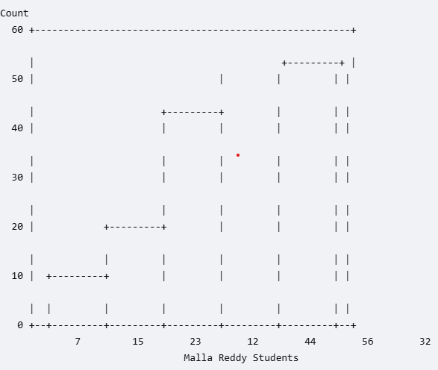

Pie Diagram or Pie Chart

Pie chart is a circular chart divided into different segments according to the ratio of data provided. The total value of the pie is 100 and the segments tell the fraction of the whole pie. It is another method to represent statistical data in graphical form and pie() function is used to perform the same.

# defining vector x with number of articles x <- c(210, 450, 250, 100, 50, 90)

# defining labels for each value in x
names(x) <- c("Algo", "DS", "Java", "C", "C++", "Python")

# output to be present as PNG file png(file = "piechart.png")

# creating pie chart
pie(x, labels = names(x), col = "white",
main = "Articles on GeeksforGeeks", radius = -1, col.main = "darkgreen")
# saving the file dev.off()

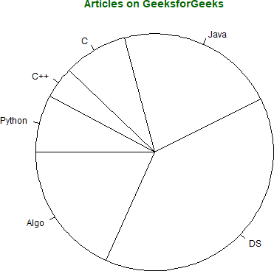

Histogram
Histogram is a graphical representation used to create a graph with bars representing the frequency of grouped data in vector. Histogram is same as bar chart but only difference between them is histogram represents frequency of grouped data rather than data itself.

# defining vector
x <- c(21, 23, 56, 90, 20, 7, 94, 12,
57, 76, 69, 45, 34, 32, 49, 55, 57)

# output to be present as PNG file png(file = "hist.png")

# hist(x, main = "Histogram of Vector x", xlab = "Values",
col.lab = "darkgreen", col.main = "darkgreen")

# saving the file dev.off()

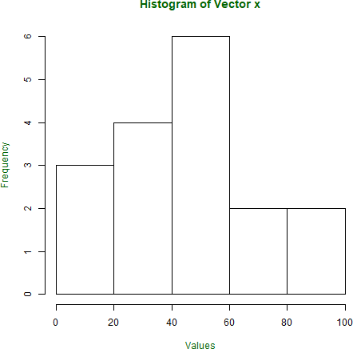

Box Plot

Box plot shows how the data is distributed in the data vector. It represents five values in the graph i.e., minimum, first quartile, second quartile(median), third quartile, the maximum value of the data vector.

# defining vector with ages of employees x <- c(42, 21, 22, 24, 25, 30, 29, 22,
23, 23, 24, 28, 32, 45, 39, 40)

# output to be present as PNG file png(file = "boxplot.png")

# plotting
boxplot(x, xlab = "Box Plot", ylab = "Age", col.axis = "darkgreen", col.lab = "darkgreen")

# saving the file dev.off()

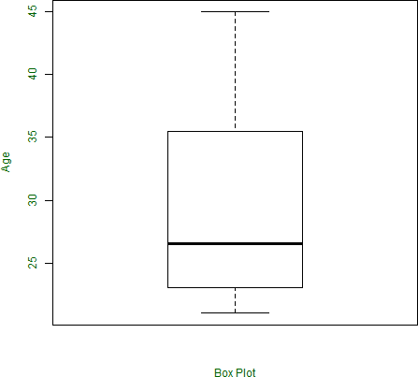

12 Use ggplot2 and implement 1) Univariate, 2) Bivariate graphs
ggplot2 is a open-source data visualization package in R based on the concept of the Grammar of Graphics.

It allows users to build complex and elegant visualizations by combining multiple layers in a structured way. Instead of writing long plotting code ggplot2 lets you construct graphs step by step using clear components.
- Based on the layered approach.
- Helps create clear, customizable and publication-quality visualizations.
- Widely used in data analysis, statistics and data science.

1. Univariate Graphs
These displays focus on a single variable to show frequency, central tendency, and skewness.

Histogram (Continuous): Visualizes the frequency distribution of a continuous numerical variable.

ggplot(data = mtcars, aes(x = hp)) + geom_histogram(binwidth = 5) + labs(title = "Histogram of Horsepower",
x = "Horsepower", y = "Count")

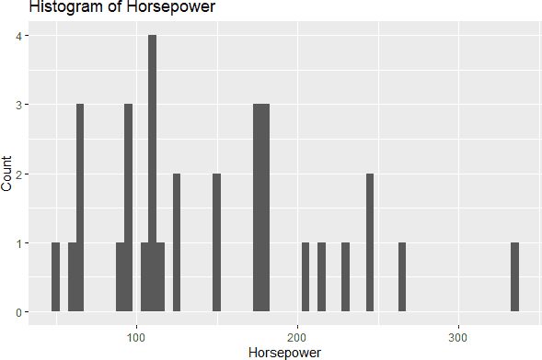

Bar Chart (Categorical): Displays the count or proportion of items in different categories

library(ggplot2)

# Create a sample data frame df <- data.frame(
id = 1:100,
category = sample(c("A", "B", "C"), 100, replace = TRUE)
)
# Plot counts of each category ggplot(df, aes(x = category)) +
geom_bar(fill = "steelblue", color = "black") + theme_minimal() +
labs(
title = "Univariate Bar Chart", x = "Category",
y = "Count"
)

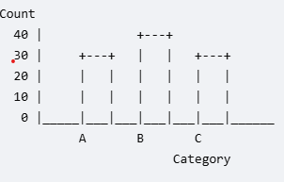

2) Bivariate graph

Scatter plot

# Load the ggplot2 library library(ggplot2)
# Create the bivariate scatter plot
ggplot(data = mtcars, aes(x = hp, y = mpg)) + geom_point() +
labs(
title = "Horsepower vs. Miles Per Gallon", x = "Horsepower (hp)",
y = "Miles Per Gallon (mpg)"
)

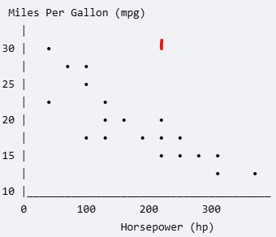

2 .Grouped Bar Plots

# importing the ggplot2 library library(ggplot2)
# creating data frame
cities <- c(rep("Delhi", 3), rep("Mumbai", 3), rep("Chennai", 3), rep("Bengaluru", 3)) humidity <- rep(c("High", "Medium", "Low"), 4)
temperature <- abs(rnorm(12, 25, 10))
dataframe <- data.frame(cities, humidity, temperature) # calling the dataframe
dataframe
# plotting the graph
ggplot(dataframe, aes(fill = humidity, y = temperature, x = cities)) geom_bar(position = "dodge", stat = "identity")
ggtitle("Weather Data of 4 Cities !") theme(plot.title = element_text(hjust = 0.5))

